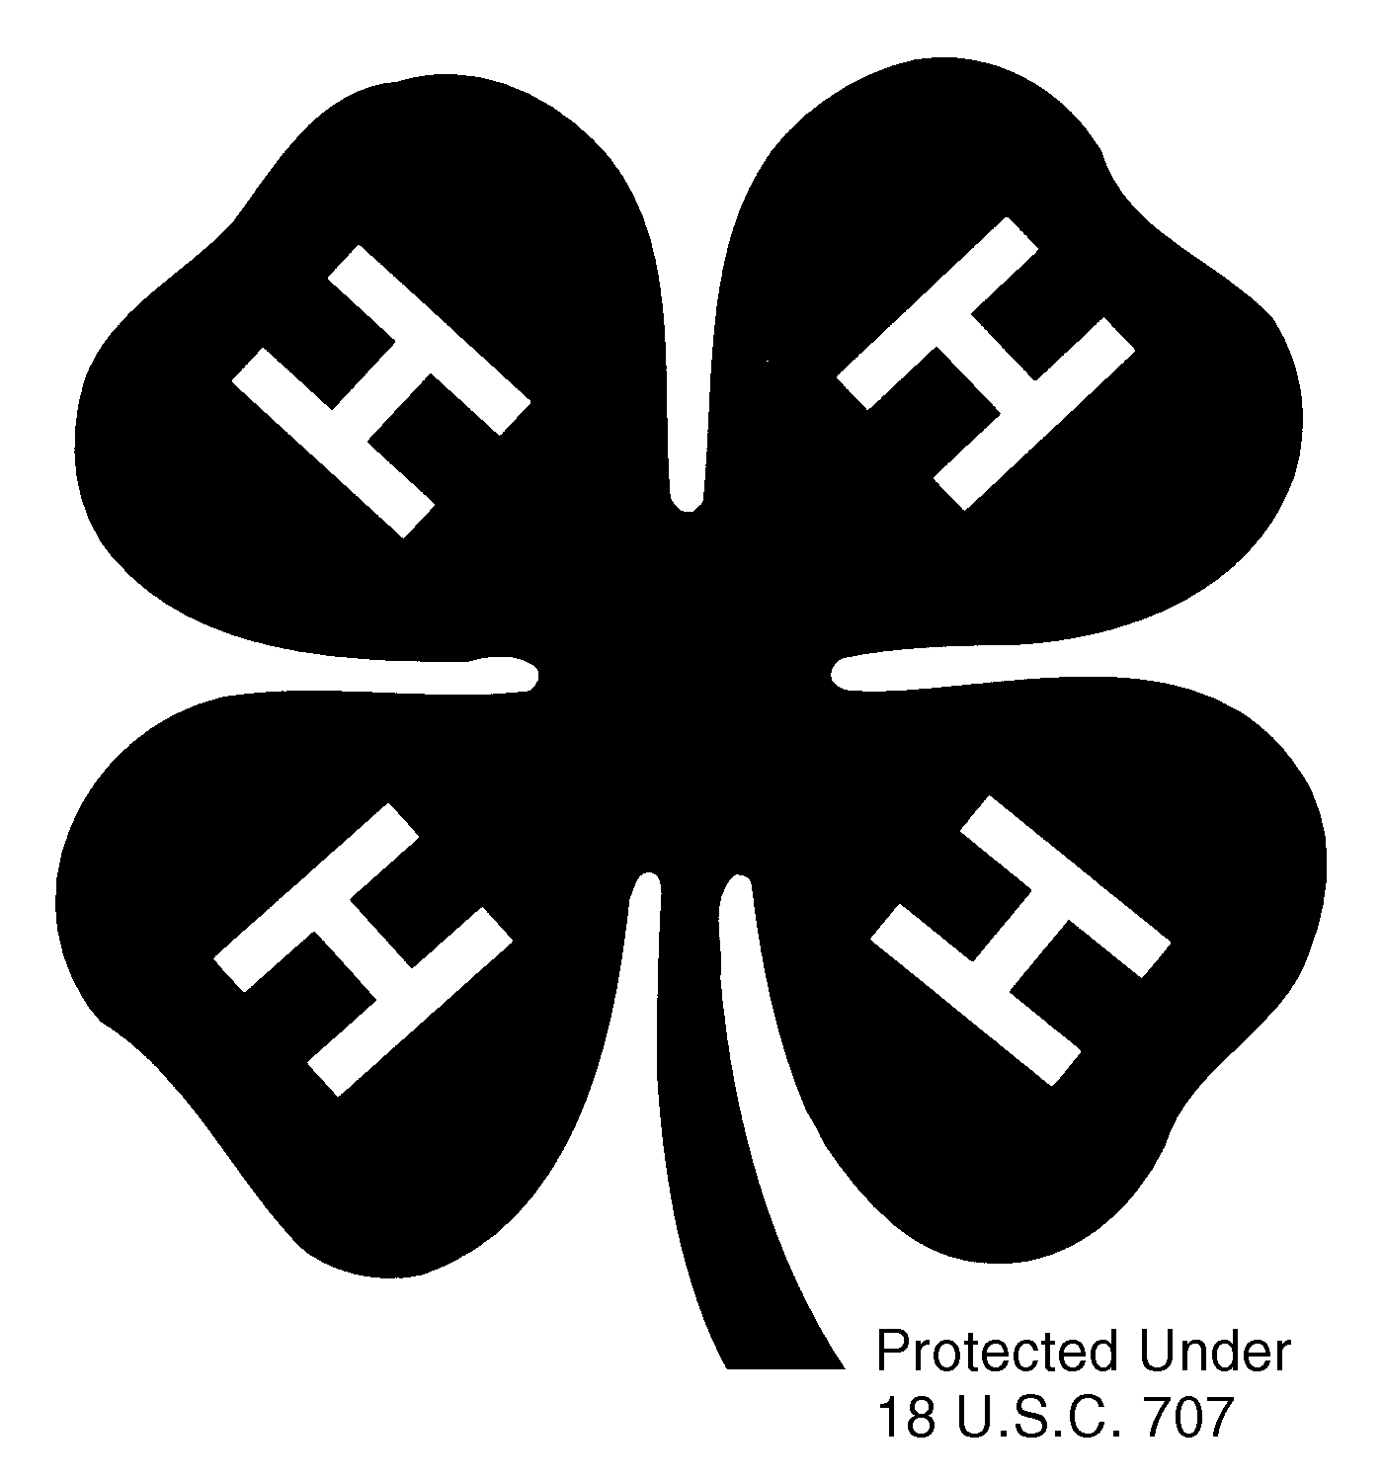

MY 4-H YEAR

This is the overall story of your 4-H year
beyond what you did in your project work.

Include your involvement and activities in these areas as applicable:

Club
(not what your club did, but what you did in your club –
how you contributed to the work of your club,
how you were involved in your club’s activities, etc.)
County
State
National

Use pictures and stories to tell what YOU did.
(Do not include project pictures; they belong in the project section.)

Pictures must be captioned.

Include this sheet in your record book as the cover page to your story.

This section needs to be tabbed.

11/2001

